

SYMBIOSIS INSTITUTE OF TECHNOLOGY, PUNE

Symbiosis International (Deemed University)
(Established under section 3 of the UGC Act, 1956)
Re-accredited by NAAC with ‘A’ grade (3.58/4) | Awarded Category – I by UGC

Founder: Prof. Dr. S. B. Mujumdar, M. Sc., Ph. D. (Awarded Padma Bhushan and Padma Shri by President of India)

Assignment No. 03

Subject: | DevOps Lab
TCODE: | TE7950
Name of Student | Atharva rale
PRN No. | 23070122174
Branch | CSE, Batch (2023-27), L3
Academic Year & Semester | 25 – 26, Sem VII
Date of Performance | 23rd July, 2026
Title of Assignment: | Simulating Git Collaboration & Conflict Resolution
Implementation: | Step 1: Make a Change on the Main Branch  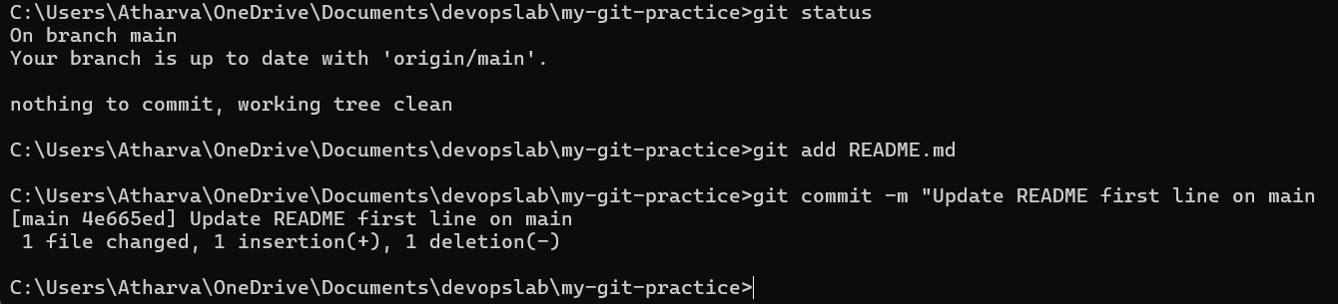  Step 2: Create a Feature Branch  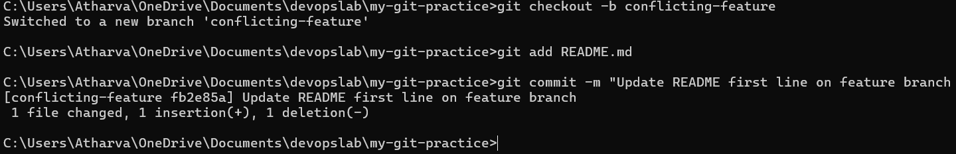

Step 3: Merge into Main
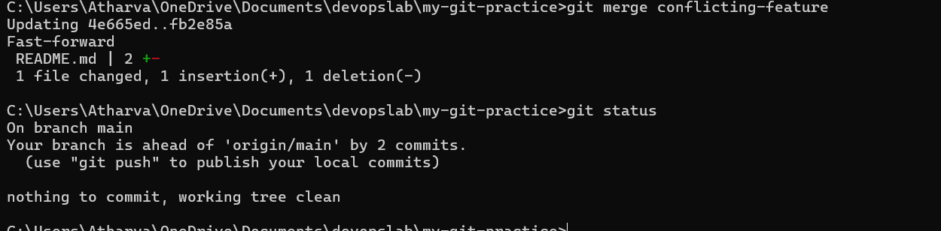

Step 4: Resolve the Conflict Step 5: Commit the Resolution Step 6: Push
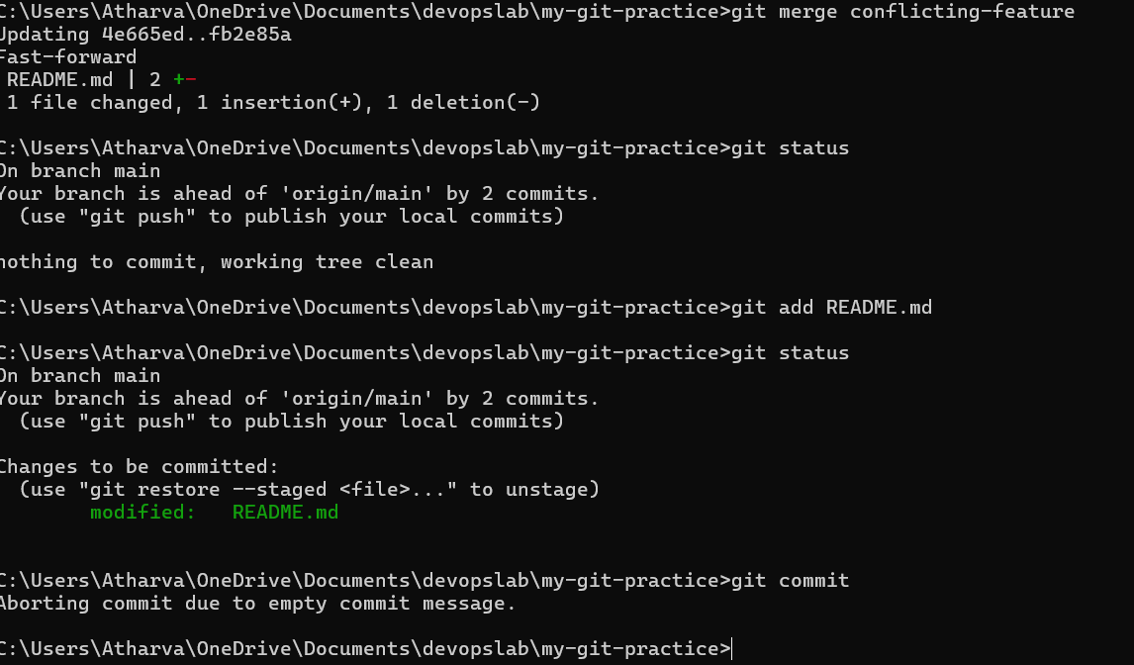

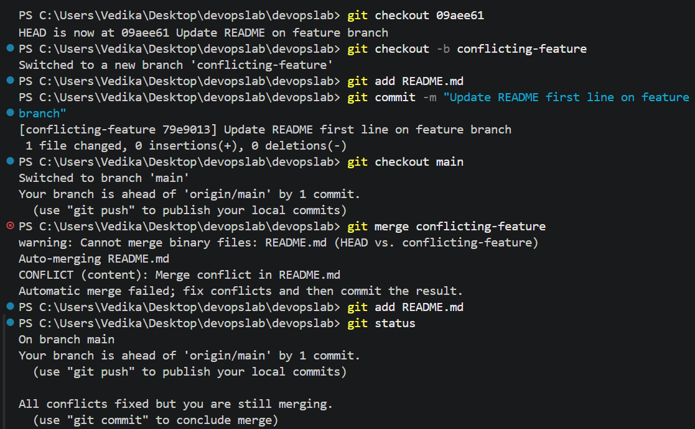

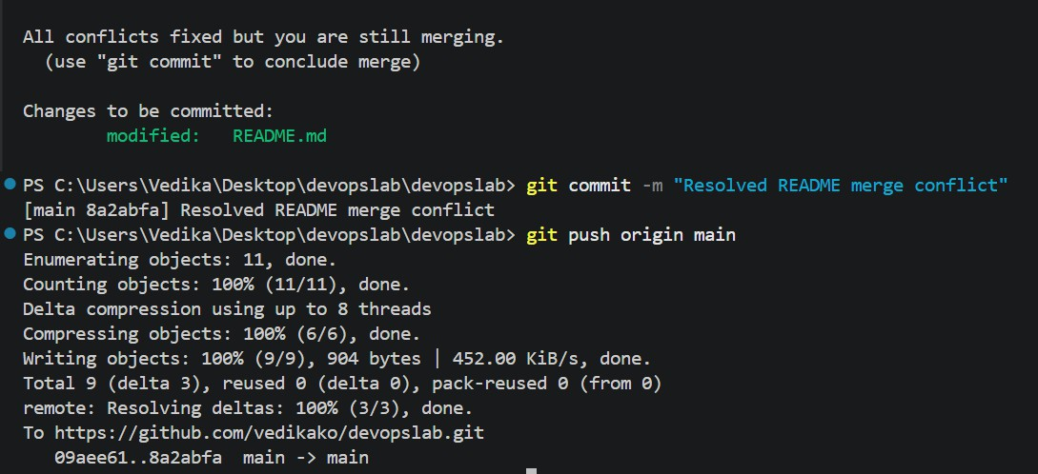

Subject Faculty Name: Prof. Arijit Dutta

